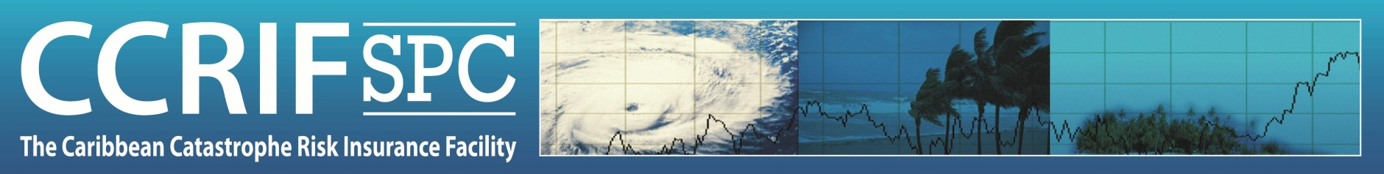
Web Monitoring Application (WeMAp)

REGISTRATION FORM
2022

Title (e.g. Dr. / Mr. / Ms.):

Name:

Position:

Organization:

Address:

Country:

Phone number:

Email address:

Other persons in your organization recommended to receive access:

Name | Position | E-mail Address

_________________________________________________________________
Please complete this form and return to:
Email: pr@ccrif.org
_________________________________________________________________

